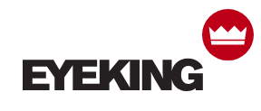

2018 Eyeking LLC
10 Hub Drive #104
Melville, NY 11747
1-866-EYEKING
info@eyeking.com

Hobie Polarized Introduces Floating Sunglasses

Melville, New York – Eyeking LLC, the licensee for Hobie Polarized introduced a floating version of the Mojo style. The floating Mojo is the first floating style introduced to the Hobie Polarized sunglass line.

The floating sunglass, known as the floating Mojo is the first floating sunglass featured by Hobie. As a brand dedicated to being out and on the water, Eyeking LLC worked with Hobie to make a product that could make dropping a pair of shades overboard less painful.

Not only does the newest edition of the Mojo float, but it features Hydro 360 Polarized Lenses, perfect for those who spend their days on and around the water to eliminate a harmful glare.

The floating Mojo is available in 4 different colorways with 4 lens options that are tailored to each individual’s needs.

###

